**Postgres Flexible Server with Geo Replication Enabled**

**Table of contents:**

1. **Creation of resource group.**
2. **Creation of Flexible server enabling geo redundant backup.**
3. **Restoring the geo backup in the paired region.**

**1.creation of resource group :**

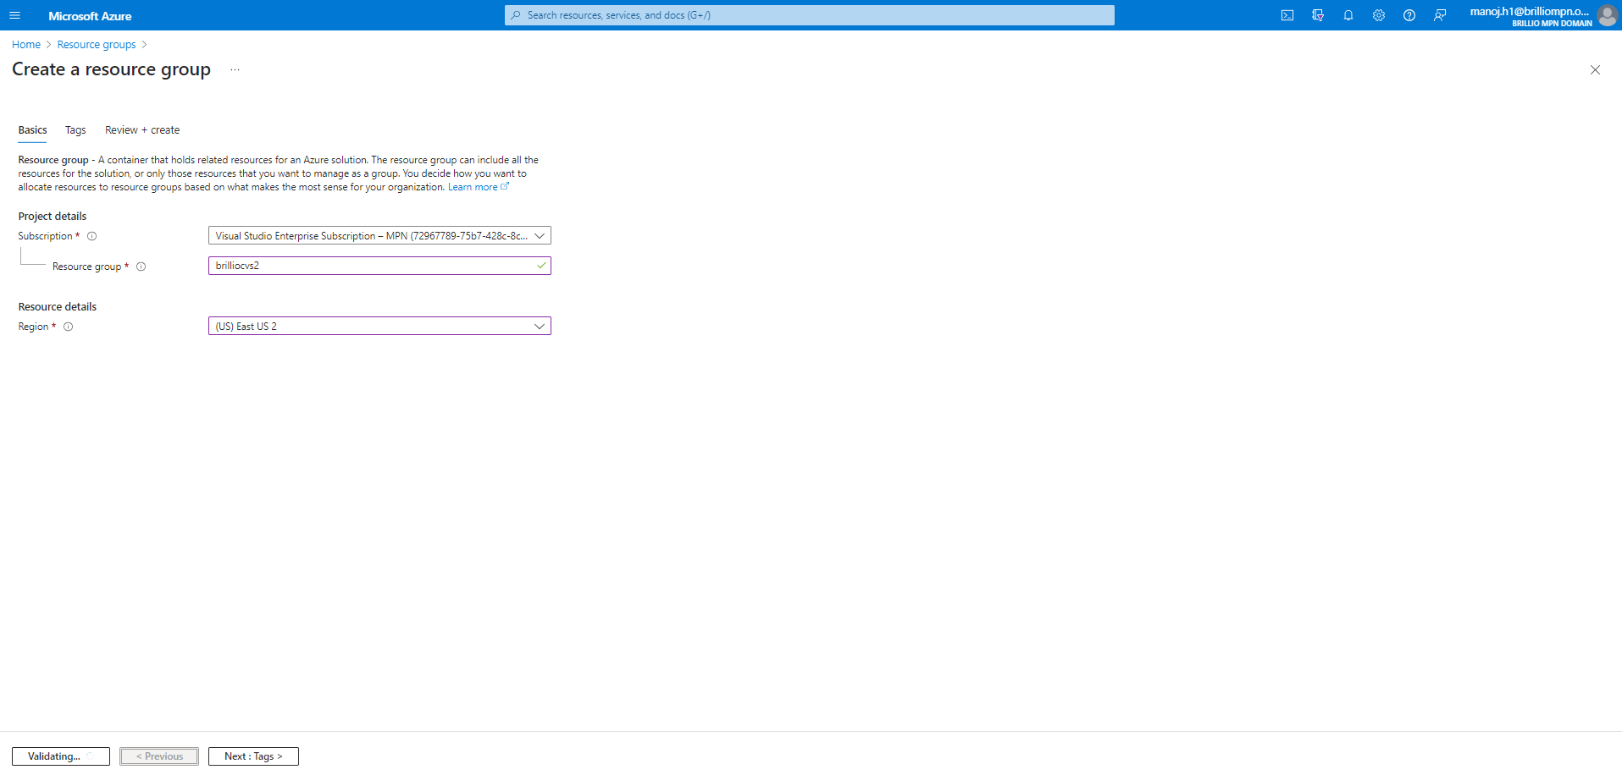

* This step shows the creation resource group in the East US2 location with the name brilliocvs2

**2. Creation of Flexible server enabling geo redundant backup:**

* Provide the resource group and server name, region, workload type, compute and storage.

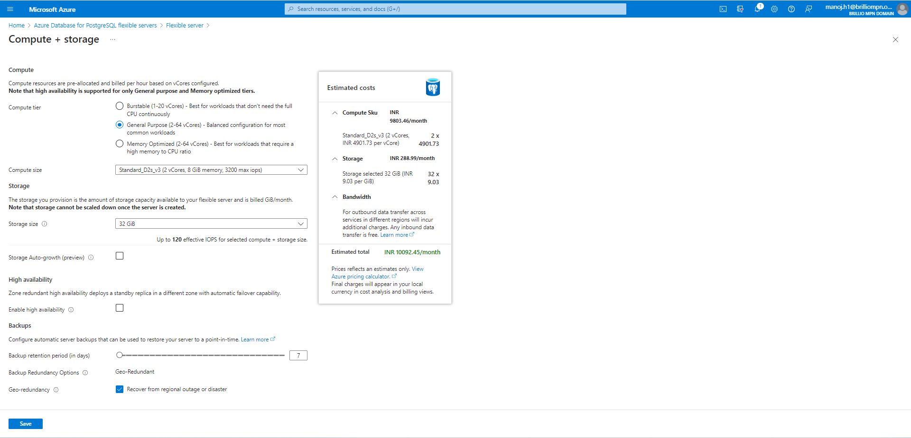

* In the compute and storage Either choose General purpose, Memory optimized. And opt for the geo redundancy.

* And provide authentication method, admin username, password.

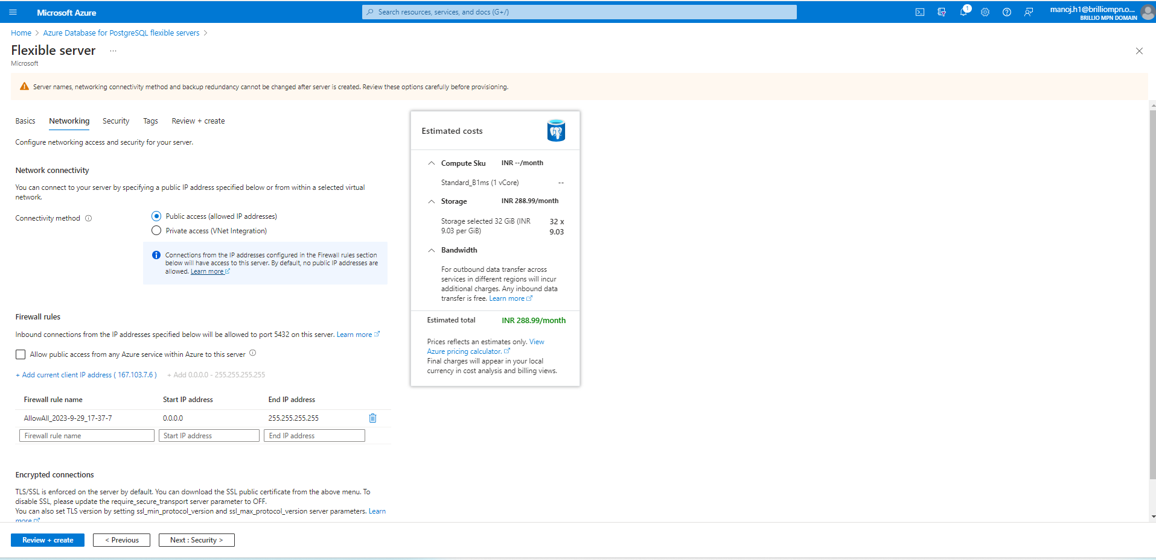

* Provide connectivity method, and firewall rules.

* Provide the data encryption method either service managed keys or customer managed keys.

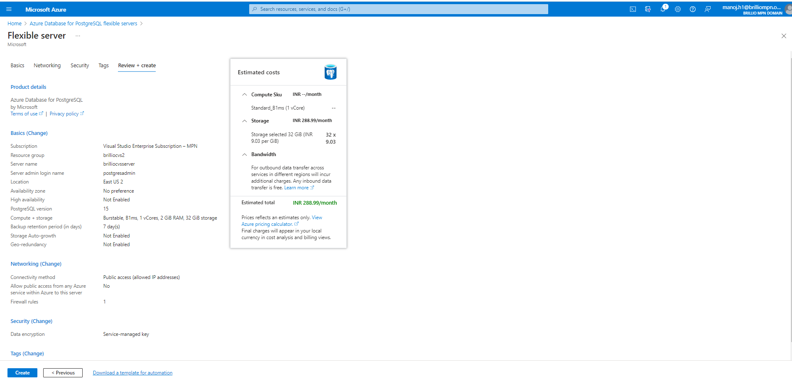

* Review the details and proceed to create the server.

1. **Restoring the geo backup in paired region.** A screenshot of a computer

   Description automatically generated

* Navigate to the backup and store and click on fast restore.

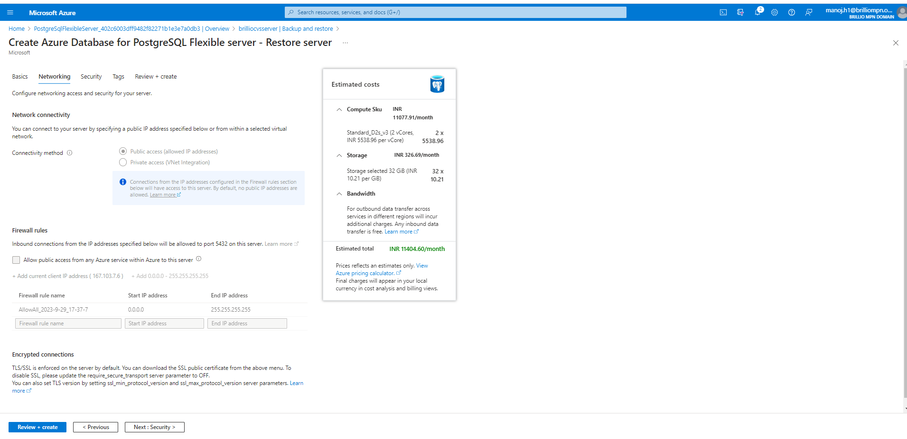

* All other fields will remain same as connectivity method, and firewall rules.

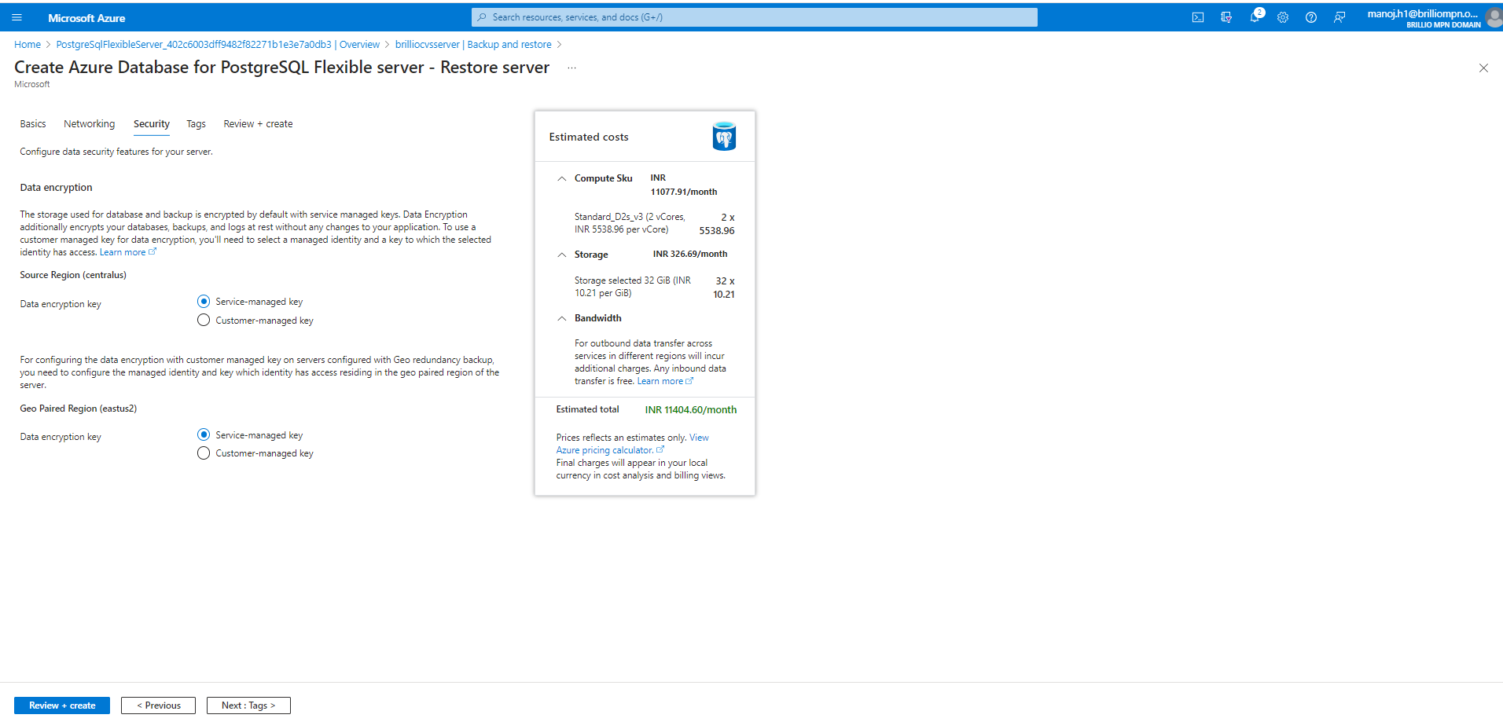

* Here also we need to specify the service managed key or customer managed key.

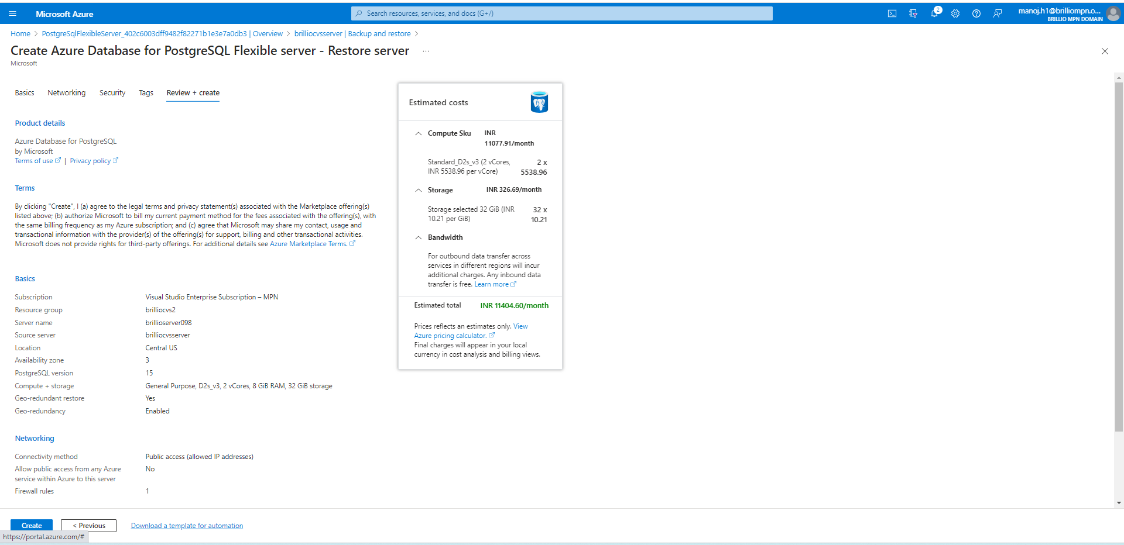

* We can review and create the server in the Paired region.